
RAMAIAH
Institute of Technology
USN | 1 | M | S

(Autonomous Institute, Affiliated to VTU)
(Approved by AICTE, New Delhi & Govt. of Karnataka) Accredited by NBA & NAAC with ‘A’ Grade

SUPPLEMENTARY SEMESTER EXAMINATIONS – JULY/AUGUST 2018

Course & Branch | : | B.E. : Electrical and Electronics Engg. | Semester | : | VI
Subject | : | Power Systems - I | Max. Marks | : | 100
Subject Code | : | EE61/EE601 | Duration | : | 3 Hrs

Instructions to the Candidates:
- Answer one full question from each unit.

 |  | UNIT- I
1. | a) | Discuss the advantages of per unit system. | CO2 | (04)
 | b) | With the help of waveforms at the time of three phase symmetrical fault on synchronous generator define steady state, transient and sub-transient reactance. | CO1 | (07)
 | c) | Draw the reactance diagram using a base of 50MVA and 13.8kV on a generator G1 for the diagram shown in Fig 1(c).  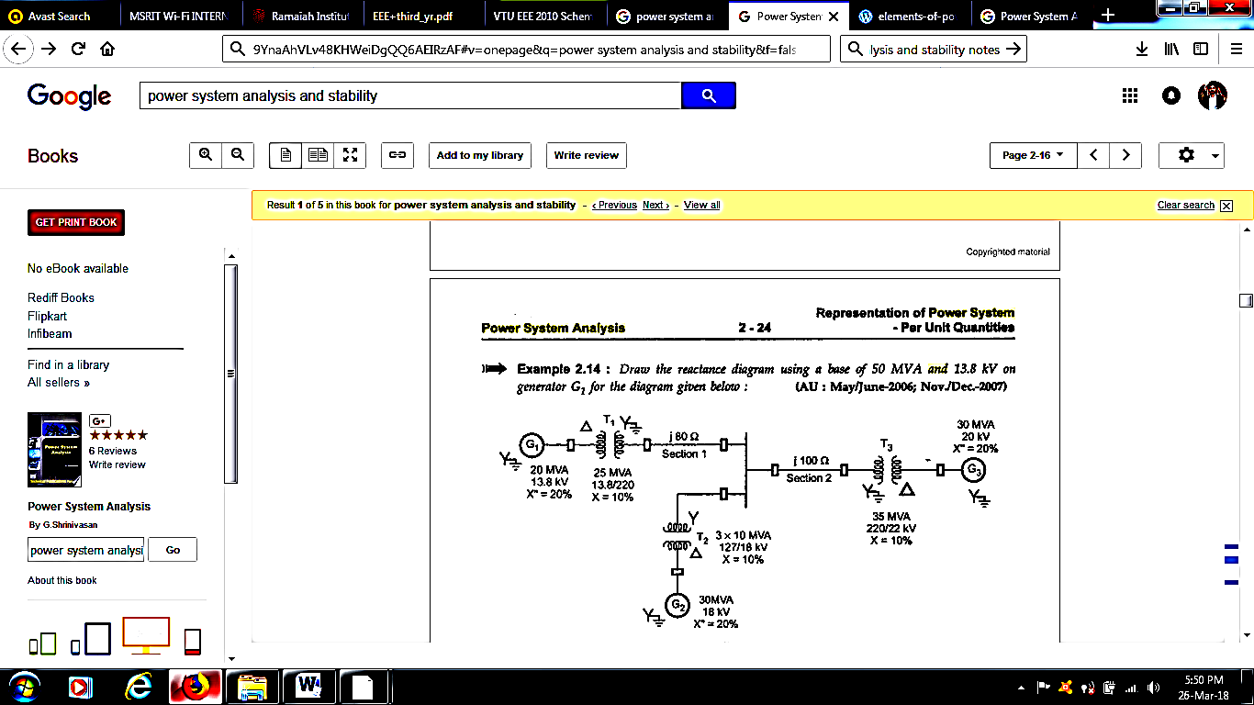  Fig 1.(c) | CO2 | (09)
2. | a) | A synchronous generator and motor are rated for 20MVA, 11kV and both have sub-transient reactance of 15%. The line connecting them has a reactance of 20% on the base of machine rating. The motor is drawing 15MW at 0.8pf lagging. The terminal voltage of the motor is 10.8kV. When a symmetrical three phase fault occurs at motor terminals, calculate the sub-transient current in generator, motor and at the fault point. | CO3 | (13)
 | b) | A 120MVA, 19.5kV generator has a synchronous reactance of 0.15pu and it is connected to transmission system through a transformer rated 150MVA, 230/18kV (star/delta) with X=0.1pu.  - Calculate the per unit reactance by taking generator rating as base values.  - Calculate the per unit reactance by taking transformer rating as base values.  - Calculate the per unit reactance for a base value of 100MVA, and 220kV on HV side of transformer. | CO2 | (07)
 |  | UNIT- II
3. | a) | Discuss the phase shifts of sequence components of voltages in the primary and secondary windings of a star-delta transformer with the help of phasor diagrams, winding diagram and connection diagram. | CO4 | (08)
 | b) | In a 3 phase 4 wire system the sequence voltages and currents are V_{a1} =0.9∟10⁰, V_{a2} =0.25∟110⁰, V_{a0} =0.12∟300⁰, I_{a1}=0.75∟25⁰, I_{a2}=0.15∟170⁰, I_{a0}=0.1∟330⁰ all in pu. Find the complex power in pu. If the neutral gets disconnected find the new power. | CO4 | (08)
 | c) | Prove that a balanced set of 3 phase voltages will have positive sequence components only. | CO4 | (04)
4. | a) | Explain the relation between sequence components of phase and line voltages in a star connected system with the help of phasor diagram. The positive and negative sequence components of phase voltages of a 3 phase system are V_{a1} =230∟30⁰V, V_{a2} =60∟60⁰. Determine the positive and negative sequence components of line voltages and hence the line voltages. | CO4 | (12)
 | b) | When a generator has terminal ‘a’ open and other two terminals are connected to each other with a short circuit from this connection to ground, typical values for the symmetrical components of current in the phase a are I_{a1}=600∟-90⁰, I_{a2}=250∟90⁰, I_{a0}=350∟90⁰ A. Calculate the current in each phase of the generator and the current in the neutral conductor. | CO3 | (08)
 |  | UNIT- III
5. | a) | A star connected synchronous generator has sequence reactances X₀=0.09, X₁=0.22, X₂=0.36 all in pu. The neutral point of the machine is grounded through a reactance of 0.09 pu. The machine is running on no load with rated terminal voltage when it suffers an unbalanced fault. The fault currents out of the machine are I_{a}=0, I_{b}=3.75∟150⁰, and I_{c}=3.75∟30⁰, all in pu with respect to phase ‘a’ line to neutral voltage. Determine: i) the terminal voltages in each phase of the machine with respect to ground ii) the voltage of the neutral point of the machine with respect to ground and iii) the type of fault. | CO4 | (10)
 | b) | Explain the sequence networks of:  i) unloaded generators ii) transmission lines. | CO4 | (10)
6. | a) | A 300MVA, 20kV three phase generator has a sub-transient reactance of 20%, supplies a number of synchronous motors over a 64-km transmission line having transformers at both ends shown in Fig. 6(a). Draw the negative and zero-sequence network for the system. Assume zero‐sequence reactances for the generator and motors of 0.05 per unit. A current‐limiting reactor of 0.4Ω is in each of the neutrals of the generator and the larger motor. The zero-sequence reactance of the transmission line is 1.5Ω/km. The motors are all rated 13.2 kV are represented by just two equivalent motors M₁ & M₂ . The neutral of motor M₁is grounded through a reactance, the second motor M₂ is ungrounded (a highly unusual situation). Rated inputs to the motors are 200 MVA and 100 kV for M₁ and M₂. The three‐phase transformer T₁ is rated 350 MVA, 230/20 kV with leakage reactance of 10%. Transformer T₂ is composed of three single-phase transformers, each rated 127/13.2 kV, 100 MVA with a leakage reactance of 10%. Series reactance of the transmission line is 0.5Ω/km. Assume that the generator and both motors have a sub transient reactance of 0.2 per unit.  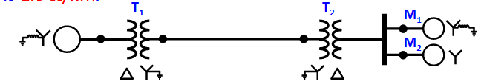  Fig. 6(a) | CO4 | (14)
 | b) | Define the positive, negative and zero sequence impedances of a synchronous machine. Obtain the sequence networks of an unloaded three phase star connected generator grounded through a reactor. | CO4 | (06)
 |  | UNIT- IV
7. | a) | Draw and explain the interconnection of sequence networks in case of i) line to ground fault ii) double line to ground fault. | CO4 | (12)
 | b) | A salient pole generator rated 20MVA, 13.8kV, with X₁= 0.25pu, X₂= 0.35pu and X₀=0.1pu. The neutral of the generator is solidly grounded. Determine the sub-transient current in the generator and the line to line voltages for sub-transient condition when an L-G fault occurs at the generator terminal with the generator operating at rated voltage. Neglect resistance. | CO4 | (08)
8. | a) | The reactances of a generator rated 100MVA, 20kV, are X_{d}”=X₁=X₂=20% and X₀=5%. The generator is connected to a Δ-Y transformer rated 100MVA, 20Δ-230Y kV, with a reactance of 10%. The neutral of the transformer is solidly grounded. The terminal voltage of the generator is 20kV when a single line-to-ground fault occurs on the open circuited, high voltage side of the transformer. Find the initial symmetrical rms current in all phases of the generator. | CO4 | (10)
 | b) | Derive the expression for the fault current in case of an L-L fault on an unloaded generator through a fault impedance. | CO4 | (10)
 |  | UNIT- V
9. | a) | Explain rotor dynamics and swing equation. | CO5 | (08)
 | b) | Define critical clearing angle and critical clearing time. | CO5 | (06)
 | c) | A 200MVA, 11kV, 50Hz, 4 pole turbo generator has an inertia constant of 6MJ/MVA. i) Find the stored energy in the rotor at synchronous speed. ii) The machine is operating at a load of 120MW when the load suddenly increases to 160MW. Find the rotor retardation. Neglect losses. | CO5 | (06)
10. | a) | A 60-Hz generator is supplying 60% of P_{max} to an infinite bus through a reactive network. A fault occurs which increases the reactance of the network between the generator terminal voltage and the infinite bus by 400%. When the fault is cleared the maximum power that can be delivered is 80% of the original maximum value. Determine the critical clearing angle for the condition described. | CO5 | (08)
 | b) | Write short notes on:  - power system stability ii) SSSL and TSL iii) equal area criterion. | CO5 | (12)

****************

